 



**December Events**

* Building Bird Houses with Dad

Wednesday, 12/7/22 from 8:30am-10:00am

* Christmas Parade Sunday, December 11th @ 2pm

If your child plans to ride the Head Start float in the parents they will need to be at the Van Buren Fairgrounds no later than 1PM. All children are to be accompanied by an adult at all times.

* School Dismisses 12/15/22 @10am

**Busses will run the morning of the 15th, but will not run in the afternoon. We need your support in picking up your child by 10 a.m. along with their holiday gifts.**

* Winter Break 12/16/22-1/2/23

**School will be closed beginning Friday, December 16th, 2022 through Tuesday, January 3rd, 2023. School will resume on Wednesday, January 4th, 2023**

12/6/22



**November Perfect Attendance**

Haisley

Gemma

Ada

Jase

Knoxleigh

Damien

Kylan

Marie

Nevaeh

Lexus

Levi

Marsali

Eli

Remington

Noah

Wyatt

**December Birthday’s**

Tavor

Eli

Cody



Van Buren County Head Start!

If you are currently not following us on Facebook please Like and

Follow Us. Some of the benefits include: photo galleries, special

news and updates, plus the ability to connect and chat online with

other people who share your interest.



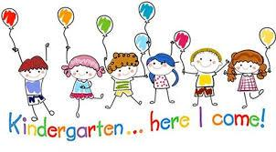Transition Talk 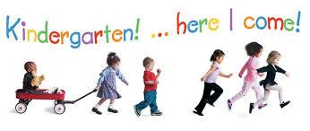

Your child will experience many changes as they transition to kindergarten in the public-school system.  One of the most significant changes will be their daily routine.  At Van Buren County Head Start our daily schedule currently consists of 2 hours and 10 minutes of center choice time where teachers interact with children and work on language, fine motor, pre-writing, cognitive, self-help and personal social skills.  The schedule also reflects one hour of gross motor time where children work on their gross motor skills through active play.  We also have two 15-minute group times where children work on social skills as well as academics.  There are transition times where children are moving from one activity to another and meal times which tallies up to our 6.5-hour day.  The kindergarten schedule consists of 1 hour of English Language Acquisition Skills and Knowledge; 1 hour of Guided Reading and Literacy Stations/RTI, 1 hour of Math, 30 minutes of outdoor time, and 30 minutes of finishing Knowledge and Math.  There is a 30-minute lunch and breakfast schedule.  Also 45 minutes fluctuates between Guidance, STEM, PE, and Library on different days of the week.  They do have a 1-hour nap time as well.  Their schedule tallies to a 7.25-hour day.  As you can see their schedule reflects increased times requiring your child to remain focused for longer increments of time.  They also will have less active play time which helps burn some energy off and adds to their attention span.  To assist your child in lengthening their attention span, you might want to try the following techniques:

1. Play focus games (example: blow bubbles and ask your child to wait until you tell them to pop them - at first allow them to pop as soon as you blow them, then increase to a few seconds, halfway to the ground, almost on the ground, etc.)
2. Divide bigger tasks into smaller tasks.
3. Understand your child’s method of learning (visual (have to see it), auditory (hear what is expected), or kinesthetic (involves movement with learning).  Once your child’s method of learning is determined, play games using their preferred method.

Working together we can assist your child with a smooth transition into kindergarten.  Thanks for your support.            Rita Mayfield Assistant Mentor Coach/Education Supervisor



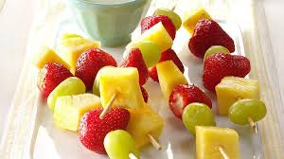Nutrition

Healthy recipes to try at home with your child/children.

Easy Overnight Oats

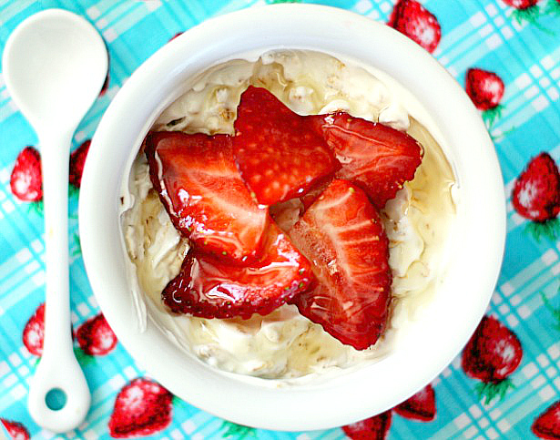

Here’s what went into the mix:

* 4-6oz container of your favorite yogurt
* 1/4 oats
* 2 tablespoons chopped dates (you can use raisins, or any dried fruit you like)
* 1/2 tsp honey
* 2-3 tablespoons milk

Mix all ingredients together, store in an airtight container and let the oats set in the fridge overnight. The oats will become nice and soft and all those delicious flavors will blend together.

****Pull the oats out the next morning. If it’s too thick for you, stir in a little milk until you get the consistency you or your kid likes. Top with fresh fruit, a drizzle of honey, and dig in.

Frozen Yogurt Banana Bites

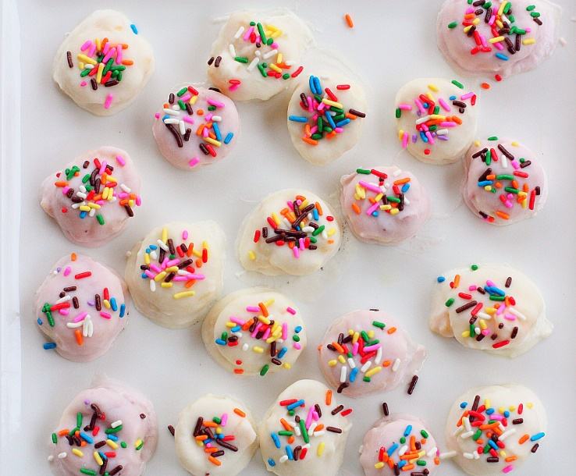

The best thing about this treat is you can use any type of yogurt you like. For this batch I used strawberry and mango yogurt, but you or your kid’s can pick their favorite flavor of the day. This is also a great snack for the kiddos to make. My girls love dipping the bananas in the yogurt, and their favorite part is the sprinkles.

You can freeze a large batch of them and store them in a freezer bag. It makes for easy freezer storage and an easy to reach snack.

Ingredients:

* 2 bananas (sliced 1/2 inch thick)
* 2 cups yogurt (your favorite flavor)
* sprinkles

Using a spoon, dip your banana slice into the yogurt and place banana on cookie sheet covered with wax or parchment paper. Repeat process with each banana. Top each banana with sprinkles. Place cookie sheet in freezer for 2-3 hours or overnight.

Enjoy!

